Insert your name, centre number and candidate number into the header above.
Save this evidence document as evidence_ followed by your centre number_ candidate number. For example: evidence_ zz999_9999.doc
Screenshots or program listings must be copied into appropriate cells in the following tables.
Examiners must be able to read the contents including any screenshots without the use of a magnifying glass. Answers that are not readable or missing will not be awarded any marks.
Save this evidence document at regular intervals, for example, every 10 minutes.
Question 1
Part 1(a)
{#DECLARE Datatored:ARRAY[0:19]OF INTEGER
#DECLARE NumberOfItems:INTEGER
global DataStored
global NumberOfItems
DataStored=[]
}

Part 1(b)
{def Initialise():
global DataStored
global NumberOfItems
Valid=False
while Valid==False:
NumberOfItems=int(input("Enter the quantity of numbers:"))
if NumberOfItems>0 and NumberOfItems<21:
Valid=True
for i in range(NumberOfItems):
usernum=input("Enter the numbers:")
DataStored.append(int(usernum))
}

Part 1(c)(i)
{NumberOfItems=0
Initialise()
print(DataStored)
}

Part 1(c)(ii)
{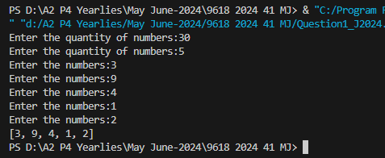 }

Part 1(d)(i)
{def BubbleSort():
global DataStored
global NumberOfItems
noswap=False
Boundary=NumberOfItems-1
while noswap==False:
noswap=True
for y in range(Boundary):
if DataStored[y]>DataStored[y+1]:
Temp=DataStored[y]
DataStored[y]=DataStored[y+1]
DataStored[y+1]=Temp
noswap=False
Boundary=Boundary-1
}

Part 1(d)(ii)
{BubbleSort()
print(DataStored)
}

Part 1(d)(iii)
{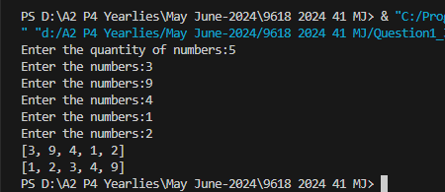 }

Part 1(e)(i)
{def BinarySearch(DataToFind):
global DataStored
global NumberItems

upperbound = NumberItems - 1
lowerbound = 0
valuefound = False
notinthelist = False

while valuefound == False and notinthelist == False:

midpoint = int((upperbound + lowerbound) / 2)

if DataStored[midpoint] == DataToFind:
valuefound = True
return midpoint
elif DataStored[midpoint] < DataToFind:
lowerbound = midpoint + 1
else:
upperbound = midpoint - 1

if lowerbound > upperbound:
notinthelist = True
return -1
}

Part 1(e)(ii)
{userinp=int(input("Enter a number:"))
Temp=BinarySearch(userinp)
print(Temp)
}

Part 1(e)(iii)
{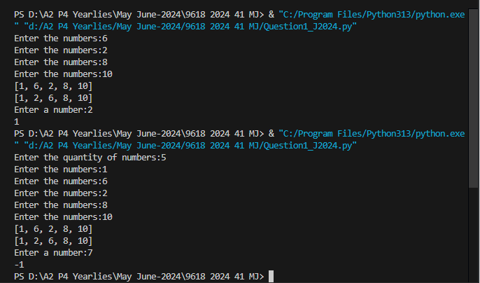 }

Question 2
Part 2(a)(i)
{class Tree():
#PRIVATE TreeName:STRING
#PRIVATE HeightGrowth:INTEGER
#PRIVATE MaxHeight:INTEGER
#PRIVATE MaxWidth:INTEGER
#PRIVATE EverGreen:STRING
def __init__(self,TreeName,HeightGrowth,MaxHeight,MaxWidth,EverGreen):
self.__TreeName=TreeName
self.__HeightGrowth=HeightGrowth
self.__MaxHeight=MaxHeight
self.__MaxWidth=MaxWidth
self.__EverGreen=EverGreen
}

Part 2(a)(ii)
{ def GetTreeName(self):
return self.__TreeName
def GetGrowth(self):
return self.__HeightGrowth
def GetMaxHeight(self):
return self.__MaxHeight
def GetMaxWidth(self):
return self.__MaxWidth
def GetEverGreen(self):
return self.__EverGreen
}

Part 2(b)
{def ReadData():
#DECLARE TreeArray[0:8] OF Tree
TreeArray=[]
try:
File=open("Trees.txt","r")
for x in range(9):
TreeData=File.readline().strip().split(",")
TreeName=TreeData[0]
Growth=int(TreeData[1])
MaxHeight=int(TreeData[2])
MaxWidth=int(TreeData[3])
EverGreen=TreeData[4]
TreeObj=Tree(TreeName,Growth,MaxHeight,MaxWidth,EverGreen)
TreeArray.append(TreeObj)
File.close()
except IOError:
print("File Doesn't Exists")
return TreeArray
}

Part 2(c)
{def PrintTrees(TreeObject):
TreeName=TreeObject.GetTreeName()
Growth=TreeObject.GetGrowth()
MaxHeight=TreeObject.GetMaxHeight()
MaxWidth=TreeObject.GetMaxWidth()
EverGreen=TreeObject.GetEverGreen()
if EverGreen=="Yes":
print(TreeName,"has a maximum height",MaxHeight,"a maximum width",MaxWidth,"and grows",Growth,"cm a year.It does not lose it's leaves")
else:
print(TreeName,"has a maximum height",MaxHeight,"a maximum width",MaxWidth,"and grows",Growth,"cm a year.It loses it's leaves each year")
}

Part 2(d)(i)
{ReturnArray=ReadData()
PrintTrees(ReturnArray[0])
}

Part 2(d)(ii)
{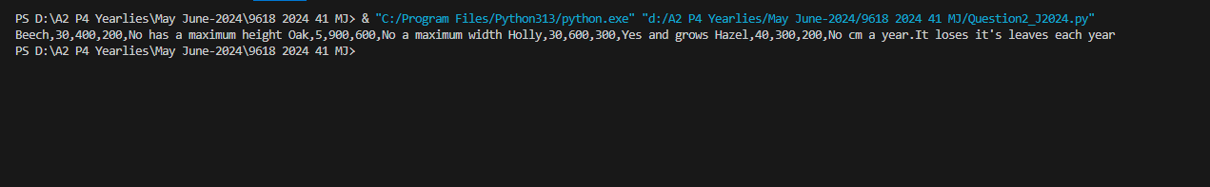 }

Part 2(e)(i)
{def ChooseTree(TreeArray):
Treeheight=int(input("Enter the tree height:"))
Treewidth=int(input("Enter tree width:"))
Evergreen=input("Enter yes or no:")
TreeArrayChoose=[]
for x in range(len(TreeArray)):
if TreeArray[x].GetMaxHeight()<=Treeheight and TreeArray[x].GetMaxWidth()<=Treewidth and TreeArray[x].GetEverGreen().lower()<=Evergreen.lower():
TreeArrayChoose.append(TreeArray[x])
if len(TreeArrayChoose)==0:
print("No matching tree")
else:
for x in range(len(TreeArrayChoose)):
PrintTrees(TreeArrayChoose[x])
}

Part 2(e)(ii)
{ Treename=input("Enter the tree name:")
TreeHeight=int(input("Enter the tree Height:"))
for x in range(len(TreeArrayChoose)):
nameTree=TreeArrayChoose[x].GetTreeName()
maxheightchosentree=TreeArrayChoose[x].GetMaxHeight()
growtheachyear=TreeArrayChoose[x].GetGrowth()
if nameTree.lower()==Treename.lower():
break
height=Treeheight-maxheightchosentree
years=int(height/growtheachyear)
print(years)
ChooseTree(ReturnArray)
}

Part 2(e)(iii)
{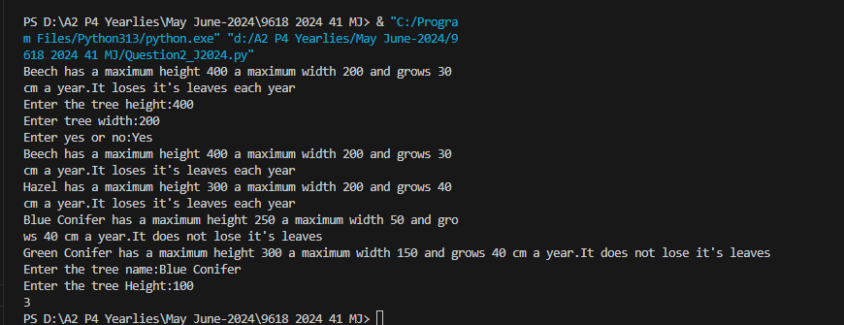 }

Question 3
Part 3(a)
{global QueueData
global QueueHead
global QueueTail

QueueData = []
for x in range(20):
QueueData.append("")

QueueHead = -1
QueueTail = -1
}

Part 3(b)
{def Enqueue(DataToInsert):
global QueueData
global QueueHead
global QueueTail

if QueueTail == -1:
QueueTail = 0

if QueueTail < 20:
if QueueHead == -1:
QueueHead = 0

QueueData[QueueTail] = DataToInsert
QueueTail = QueueTail + 1
return True
else:
return False
}

Part 3(c)
{def Dequeue():
global QueueData
global QueueHead
global QueueTail

if QueueHead == -1:
return "false"
else:
item = QueueData[QueueHead]
QueueHead = QueueHead + 1

if QueueHead == QueueTail:
QueueTail = -1
QueueHead = -1

return item
}

Part 3(d)(i)
{def StoreItems():
global QueueHead
global QueueData
global QueueTail

invalidcount = 0

for x in range(10):
Data = input("Enter the Data: ")

Total1 = int(Data[0]) + int(Data[2]) + int(Data[4])
Total3 = (int(Data[1]) * 3) + (int(Data[3]) * 3) + (int(Data[5]) * 3)
Total = Total1 + Total3
CheckDigit = int(Total/10)

if (CheckDigit == 10 and Data[6] == "X") or CheckDigit == int(Data[6]):
Result = Enqueue(Data[0:6])

if Result == True:
print("Data Inserted")
else:
print("Queue is full")
else:
invalidcount = invalidcount + 1

print("There were", invalidcount, "Invalid Items")
}

Part 3(d)(ii)
{StoreItems()

flag = Dequeue()
if flag == "false":
print("Queue is empty")
else:
print("Dequeued Value: ",flag)
}

Part 3(d)(iii)
{ 

